**Keynote speech（Other new energy and development trends）**

In addition to the solar and wind energy introduced by the above two speakers, at present, there are many new energy sources, such as water energy, biomass energy, tidal energy, geothermal energy, hydrogen energy, nuclear energy, combustible ice and so on.

Next, the characteristics of new energy sources are summarized as follow:

First, they are renewable and rich in resources; second, environmentally friendly, they produce less carbon and have less impact on the environment; third, wide distribution, so they conducive to small-scale distributed utilization; forth, intermittent supply, which is unfavorable for continuous energy supply because of the large volatility; and the last point is the higher development and utilization costs.

The picture presents world energy structure in recent years. First, we can see from the picture that oil and coal are still the world's major sources of power generation at present. Second, new energy accounts for a very small proportion in the global energy consumption structure (the degree of emphasis and policy, the cost of technology is high), however, in recent years, new energy generation has faster growth.

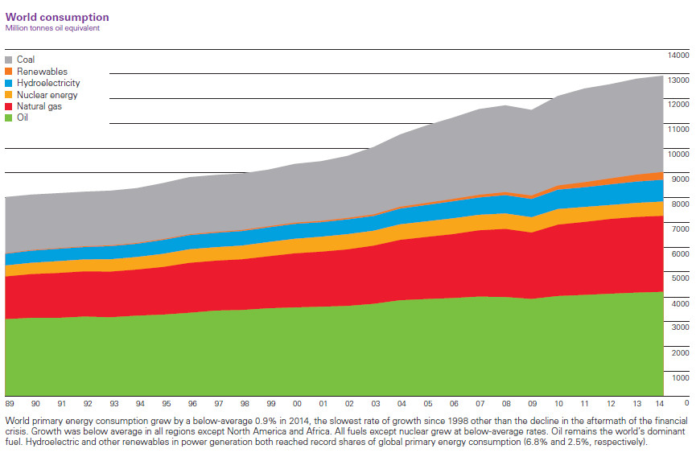

Figure 1. World energy structure diagram

What’s more, we can see from the picture that, in 2015, global wind power generation accounted for 3.87% of total power generation, and photovoltaics accounted for 1.34%, which together accounted for only 5.2%, but because of the potential for cost reduction, their growth trend is rapid, they will surely become the mainstream of alternative energy in the future.

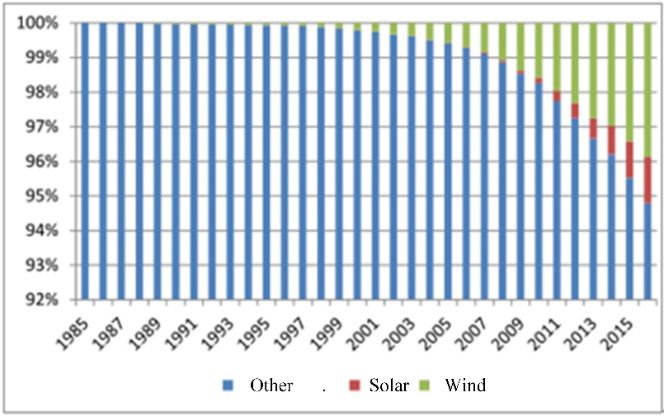

Figure.2 Accounts of Solar and Wind generation in total power generation

At last, we can see from the picture that, the world is at the key node of energy substitution. Energy substitution is accelerating. It is predicted that the global energy structure will change dramatically by 2050, which will greatly improve environmental and energy security issues.

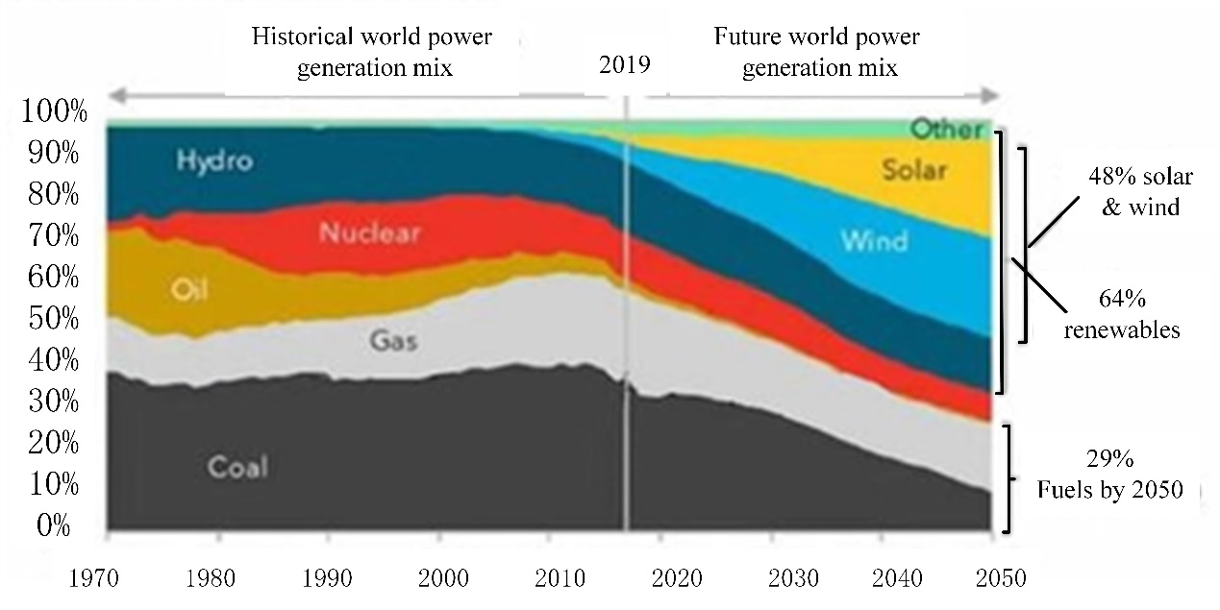

Figure.3 Prediction of global power generation structure.